**REACT**

**Day-7 14-12-2022 T SREE SOWMYA**

**CSE-04 IV YEAR**

**221910304044**

**Program on Conditional rendering(if)**

1q) Create a functional Component “your name” create state ,CSE and assign value “null” . In a declaration of State Component ,declare one more updated variable CSE-1.If value of CSE-1 is true print “yourname” , if it is false print your pin num.

import React,{useState} from 'react'

function GitamSowmya()

{

 const[CSE,setCSE1]=useState(true);

 return(

      CSE?<h1>Sowmya</h1>:<h1>221910304044</h1>

 );

}

export default GitamSowmya;

**App.js**

import './App.css';

import {useState} from 'react';

import GitamSowmya from './GitamSowmya';

import Student from './Student';

//import User from './User'

import React,{Component} from 'react';

class App extends Component

{

render()

{

return (

    <div>

<GitamSowmya/>;

</div>

);

}

}

export default App;

**2q)**

import './App.css';

import {useState} from 'react';

import Gitamhyd from './Gitamhyd';

import Student from './Student';

//import User from './User'

import React,{Component} from 'react';

function App()

{

    return(

        <div className="App">

        <Gitamhyd/>

        </div>

    );

}

export default App;

**Gitamhyd.js:**

import React,{useState} from 'react'

function Gitamhyd()

{

    const[CSE1,setCSE1]=useState(1)

    return(

    <div>

    {

      CSE1==1?<h1>ECE</h1>: CSE1==2?<h1>Mech</h1>: <h1>T Sree Sowmya</h1>

    }

    </div>

    );

}

export default Gitamhyd;

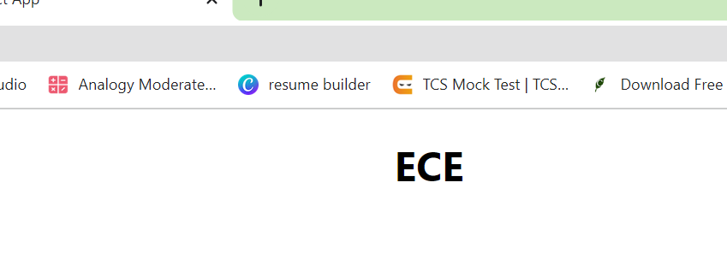

3q)

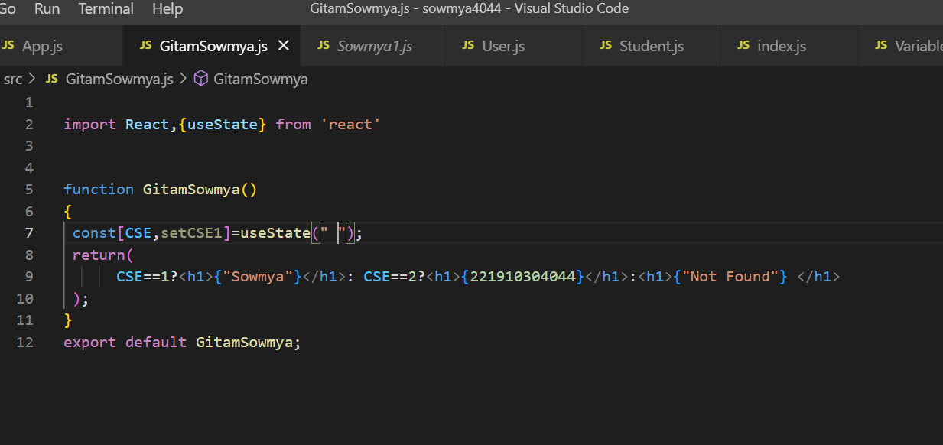

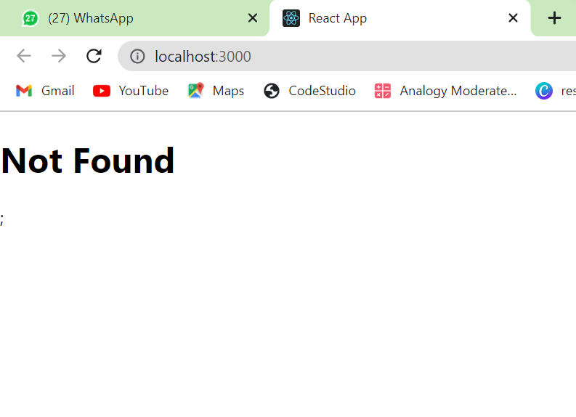

4q)

**Create a text field,whatever is entered in text field that matter should display above text field.**

import './App.css';

import {useState} from 'react';

import GitamSowmya from './GitamSowmya';

import Student from './Student';

//import User from './User'

import React,{Component} from 'react';

function App()

{

    const[data,setData]=useState(" ")

    function getData(val)

    {

        setData(val.target.value)

    }

    return(

        <div className="App">

        <h1>{data}</h1>

        <input type="text" onChange={getData}/>

        </div>

    );

}

export default App;

